Student: Xucheng You

E-mail: [xuyo7554@colorado.edu](mailto:xuyo7554@colorado.edu)

Faculty Supervisor: Arielle Blum

E-mail: [amblum@colorado.edu](mailto:amblum@colorado.edu)

# Project Summary – Developing Computer Vision Workshop

As machine learning is growing fast recent years, it has been applied to more and more products close to our everyday lives. People find this is a tool that could be widely used in many fields of study. As an Electrical Engineering student always interested in cutting edge technologies, this “developing computer vision workshop” project brings up my interests to do some research related to the machine learning topic. This project is intended to first let the DLA student learn basic machine learning knowledge from online course, then working together with supervisor to develop a 2-hour long workshop which contains entry-level machine learning materials based on the student’s learning experience to and understanding to topics. This workshop should be designed for any engineering student regardless of their math and programming experience. This workshop is meant to bring up students’ interest in machine learning and prepare them for further studying on this topic and next-level workshops. In order to do this, and to make the workshop attractive. Supervisor and student would pick several (3-5) most important topics and do animations for them, which could help students new to this field to see machine learning in a more straightforward way, also helping instructor explain abstract concepts better in the middle of workshop.

As to the technical background of this project, most of it will be related to supervised learning, which means using training dataset to help machine learn from previous results. As I am learning machine-learning from the beginning myself and doing research at the same time, the topics I have gone through so far are Linear regression, logistic regression, classification, neural network, etc. These algorithms are different because each of them is more suitable for one type of problems. But they are also internally connected, they share the basic concept of data analysis, they have similar ways to be implemented, for instance, they all need steps doing cost function calculation and gradient descent updating in every iteration. These are the first few topics a beginner would learn and practice, they are not only simple topics to get started with, but also useful in practical problem solving. The technical material related to machine learning also includes linear algebra and programming, they are not indispensable for starting this project but definitely helpful in understanding the concepts and algorithms of the topics.

Machine learning could fit in with other research as well, which also helps students involved in this workshop use machine learning as a tool in further research projects. For example, popular projects today like face detection, autonomous driving, deep learning are all using machine learning algorithms. More generally, machine learning could fit in all fields which has a large set of data and with multiple features to be analyzed. After training, it could predict future single data points or the trend of curve. So it works best for problems like weather forecast, housing prices predicting, spam e-mail classification, etc.

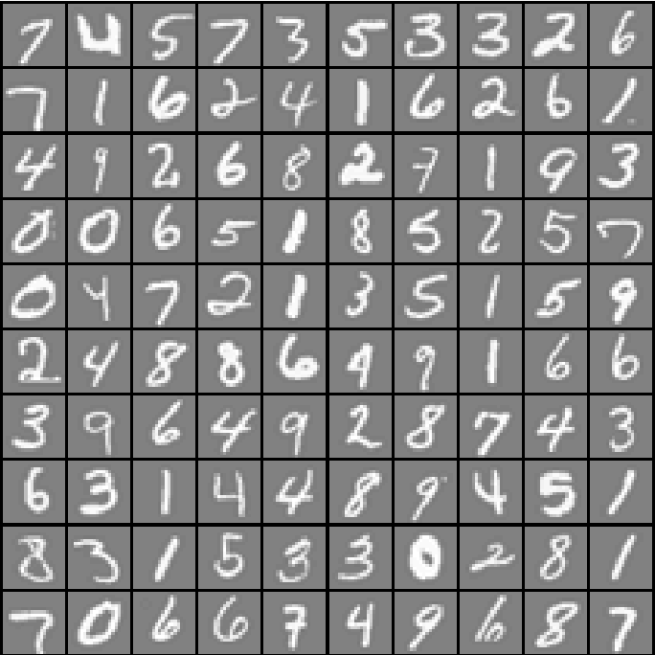 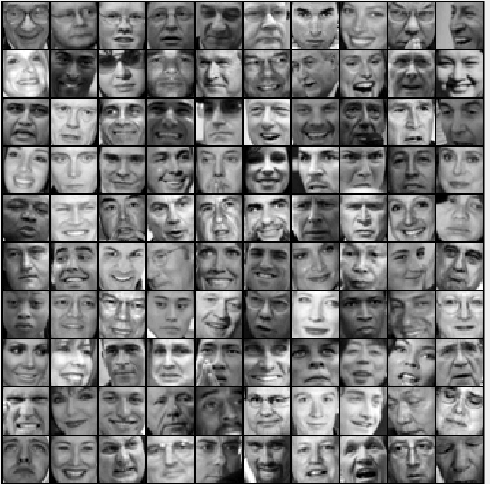

Figure 1: Machine learning example:

face detection and handwriting recognition

During the project, both machine-learning coding practice and animation design will be mostly done using MATLAB because MATLAB has integrated library needed for doing linear algebra calculations. MATLAB is also friendly with data input, data plotting. It is a powerful and easy-to-use tool to implement algorithms. It could shorten the program to a few lines comparing with hundreds of line in other programming language. The new app designer in MATLAB is designed well for creating a user interactive interface with dataset as input. It has built-in icons which saves the effort of designing it form sketch, the interface created could also be converted to code blocks for detailed modification. It also support using function like get-frame to turn it into a gif file to show how the program deals with data points step by step. For the place of this workshop, the idea forge has open space that could be used for our workshop pilot run.

According to our plan and goals, which is designing a entry-level machine learning workshop before January, supervisor and me came up with a timeline for this semester and winter break (Figure 2). We will try our best following this timeline, if this goes well, we will start designing moderate level workshops next semester.

Timeline (GANTT chart):



Figure 2: Timeline GANTT chart

Supervisor Signature: ____________________ Date: _____________________